RPA PRACTICALS

\*Create a simple sequence-based project.

"Hello" & Name & "!" & "Welcome to UIPATH"

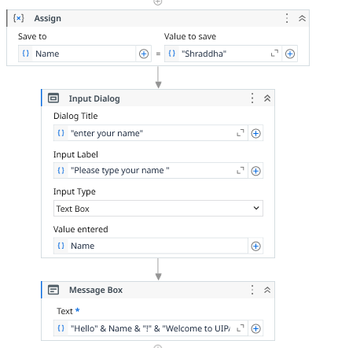



\*Automate any process using basic recording.

\*Automate any process using a desktop recording.

\*Automate any process using web recording . (u can do for amazon)

USE WEB APP RECORDER

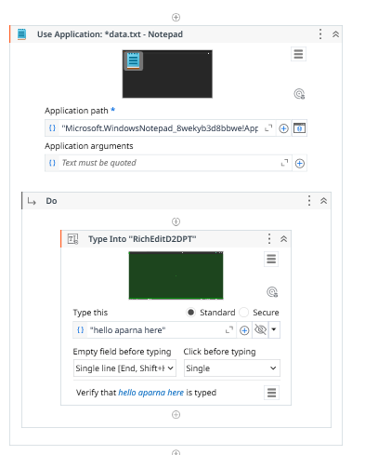

\*Automate the process of launching an assistant bot on a keyboard event.

\*Create PDF Automation to Read PDF With OCR.

Create a variable pdftext

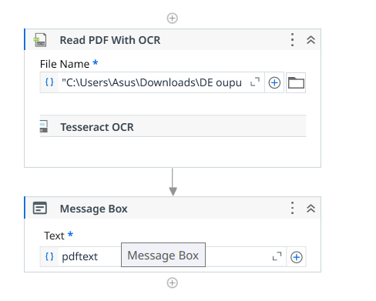

\*Create a simple flowchart-based project. Create an automated UiPath Project using the if Else Activity.

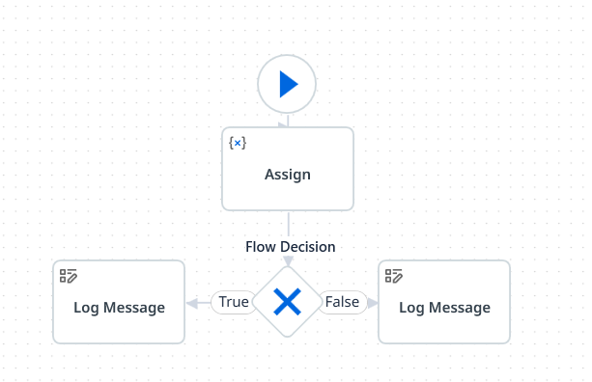

Number Mod 2 = 0 # condition

\*Demonstrate switch statement with an example.

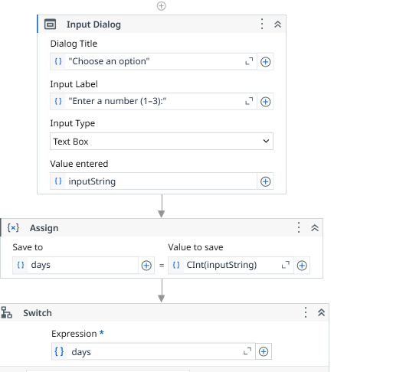

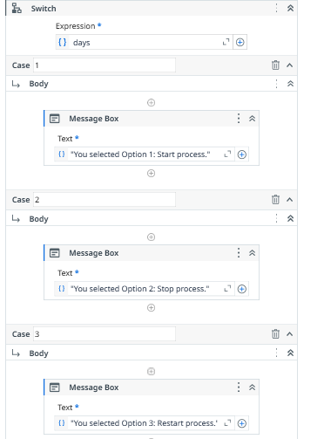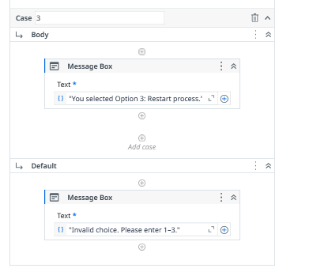



\*Consider an array of names. We have to find out how many of them start with the letter "c". Create an automation where the number of names starting with "c" is counted and the result is displayed.

\*Consider an array of names. We have to find out how many of them start with the letter "a". Create automation where the number of names starting with "a" is counted and the result is displayed.

\*Consider an array of names. Find out how many of them start with the letter "R". Create automation where the number of names starting with "R" is counted and the result is displayed.

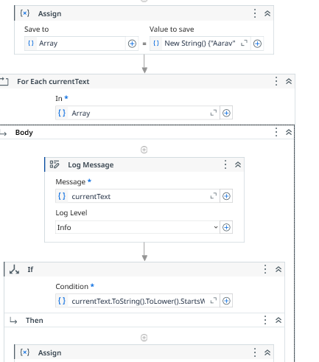

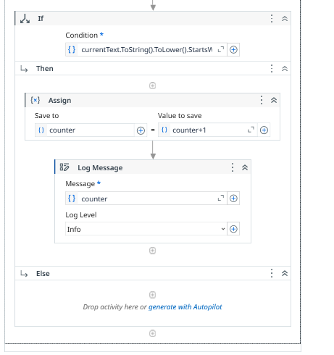

currentText.ToString().ToLower().StartsWith("a") #condition

New String() {"Aarav", "Anaya", "Ayaan", "Mira", "Rohan", "Kavya", "Ishaan", "Tara", "Dev", "Nisha"}(0)

\*Automate UiPath Number Calculation (Addition, Subtraction, Multiplication, Division of numbers).

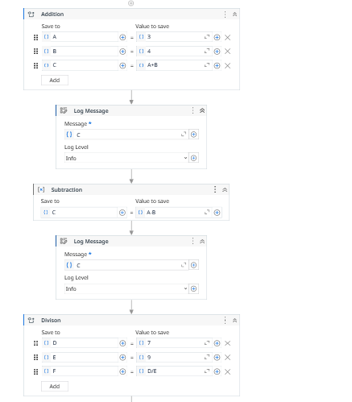

\*Demonstrate Exception Handling using UiPath.

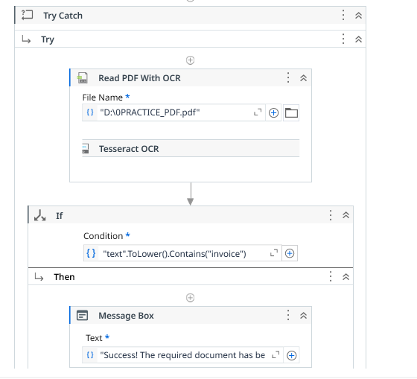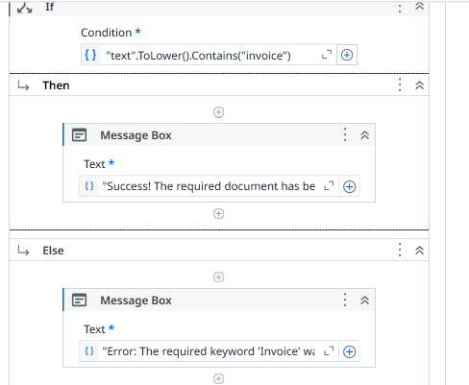

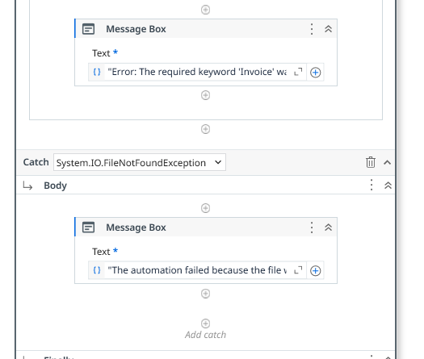

\*Create an automation To Print numbers from 1 to 10 with break after the writeline activity inside for each activity.

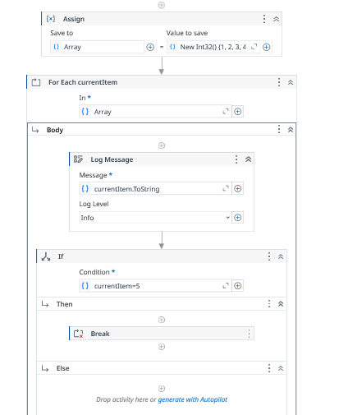

\*Create automation in UiPath Project using Do while statement.

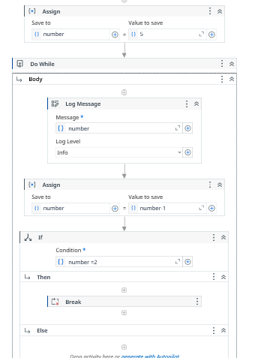

\*Create an automation To Read and Write data to specific cell of an excel sheet.

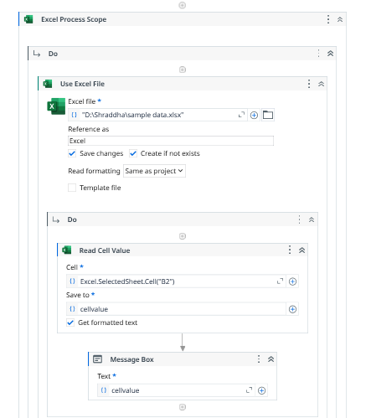

\*Automate the process to extract data from an excel file into a data table and vice versa.

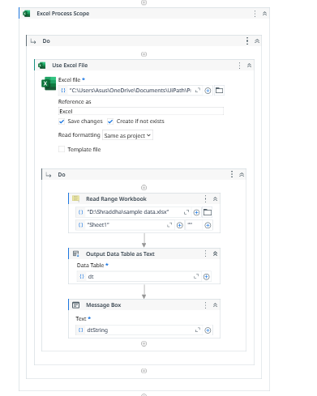

\*Create an automation to perform append range activity.

\*Create an application automating the read, write and append operation on excel file.

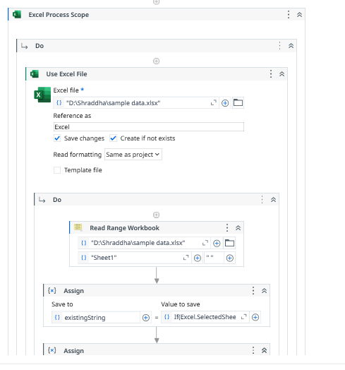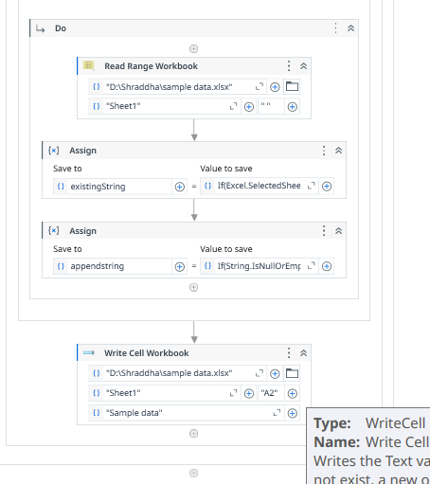

\*Create an automated UiPath Project using For each loop.

\*Create an automated UiPath project using different types of variables (number, DateTime, Boolean, generic, array, data table).

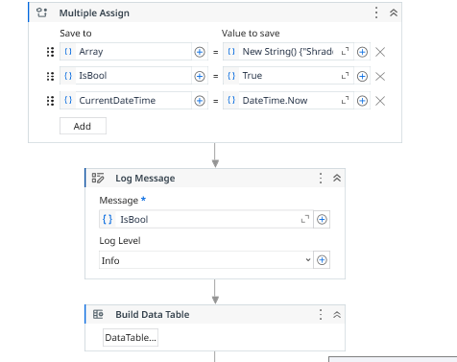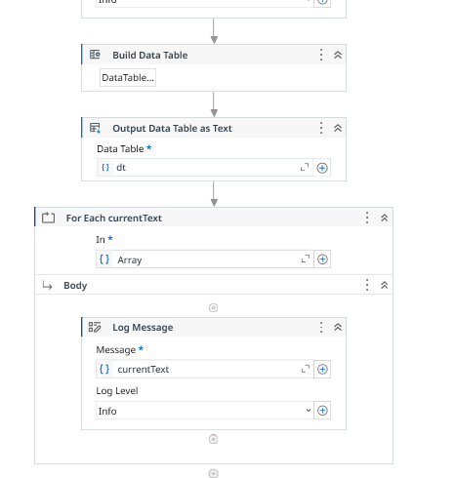

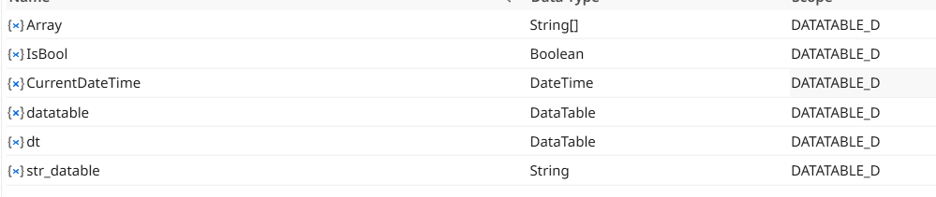

\*Create a UiPath automation Debugging that includes: Step into, Step over, Step out.

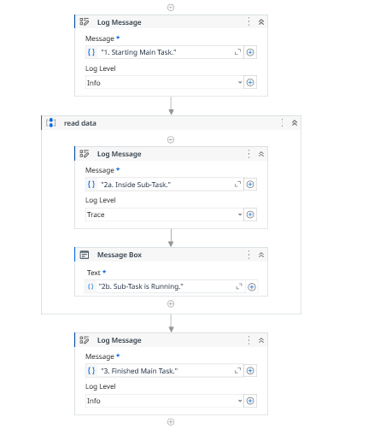

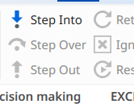

\*Create a UIPATH project using decision making statements.

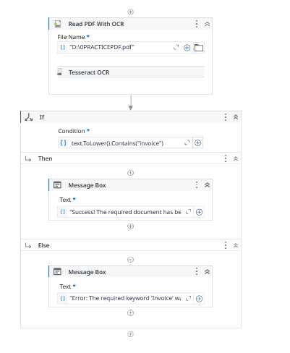TIP: use pdf that has image jiska text can’t becopied

\*